Name_Todd Carter____________________ Mark _____________________/50

## Brief introduction __/3

My feature will be to implement viable non-player characters that will interact with the player through combat and dialogue. The NPCs will be able to attack and fight the player, and the player will have the option to talk with each of them.

## Use case diagram with scenario __14

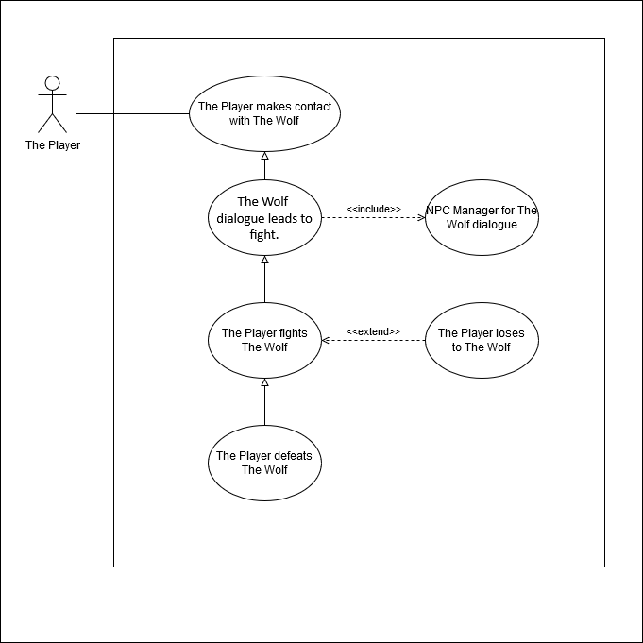

### Scenarios

**Name:** The Wolf dialogue leads to fight.

**Summary:** The player activates The Wolf and the player selects dialogue options, which eventually leads to a fight.

**Actors:** Player and The Wolf.

**Preconditions:** Player made contact with The Wolf.

**Basic sequence:**

**Step 1:** The Wolf displays text box that says, “Oh? Little Red Riding Hood, in these woods again? I thought you knew better than to come around here!”

**Step 2:** A dialogue box above the player will display, “I should have expected to find your mangy hide here, Wolf! It was YOU, wasn’t it?!”

**Step 3:** A dialogue box above The Wolf will display, “You’ve been gone from these woods too long, Red! You don’t know how things work around here anymore!”

**Step 4:** A dialogue box above the player will display, “I know enough about YOU, Wolf! You always had it in for Grandmother!”

**Step 5:** A dialogue box above The Wolf will display, “So what if I did? What, did someone finally whack the old broad?”

**Step 6:** A dialogue box above the player will display, “How dare you! I’ll kill you for that!”

**Step 7:** A dialogue box above The Wolf will display, “You can try, Red! Show me what you got!”

**Step 8:** The Wolf becomes hostile and attacks the player.

**Exceptions:**

**Step 1.1:** The player pushes any button besides the activation or attack. The Big Bad Wolf does not activate.

**Step 1.2:** The player pushes the attack button instead of the activation button. This triggers an immediate fight with the Big Bad Wolf.

**Post conditions:** The Wolf is changed to hostile.

**Priority:** 2*

**ID:** N01

*The priorities are 1 = must have, 2 = essential, 3 = nice to have.

**Name:** The player fights The Wolf.

**Summary:** The player completed the dialogue or has attacked The Wolf, and in response The Wolf has turned hostile.

**Actors:** Player, The Wolf.

**Preconditions:** The Wolf has been turned hostile.

**Basic sequence:**

**Step 1:** The Wolf starts to approach the player.

**Step 2:** The player uses their attack to fend off The Wolf.

**Step 3:** When The Wolf is defeated, a dialogue box above The Wolf will display, “Always knew… I couldn’t beat you… It takes a human… to kill a human… Just like Grandmother found out…”

**Step 4:** The Wolf sprite changes to dead.

**Step 5:** The passageway to the next zone of the game is opened.

**Exceptions:**

**Step 2.1** The player is defeated by The Wolf. This results in an immediate Game Over screen.

**Post conditions:** The Wolf is changed to dead, the next zone is opened.

**Priority:** 2*

**ID:** N01

*The priorities are 1 = must have, 2 = essential, 3 = nice to have.

## Data Flow diagram(s) from Level 0 to process description for your feature _______14

Context Diagram:

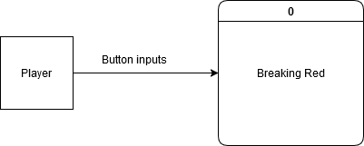

Data Flow Diagram 0:

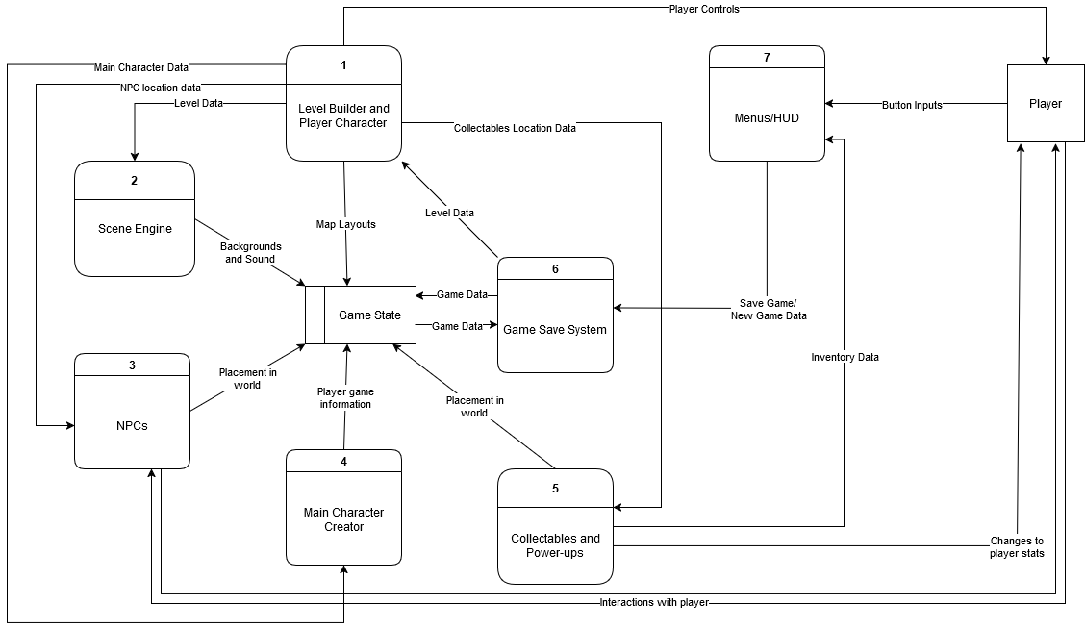

Data Flow Diagram Level 1:

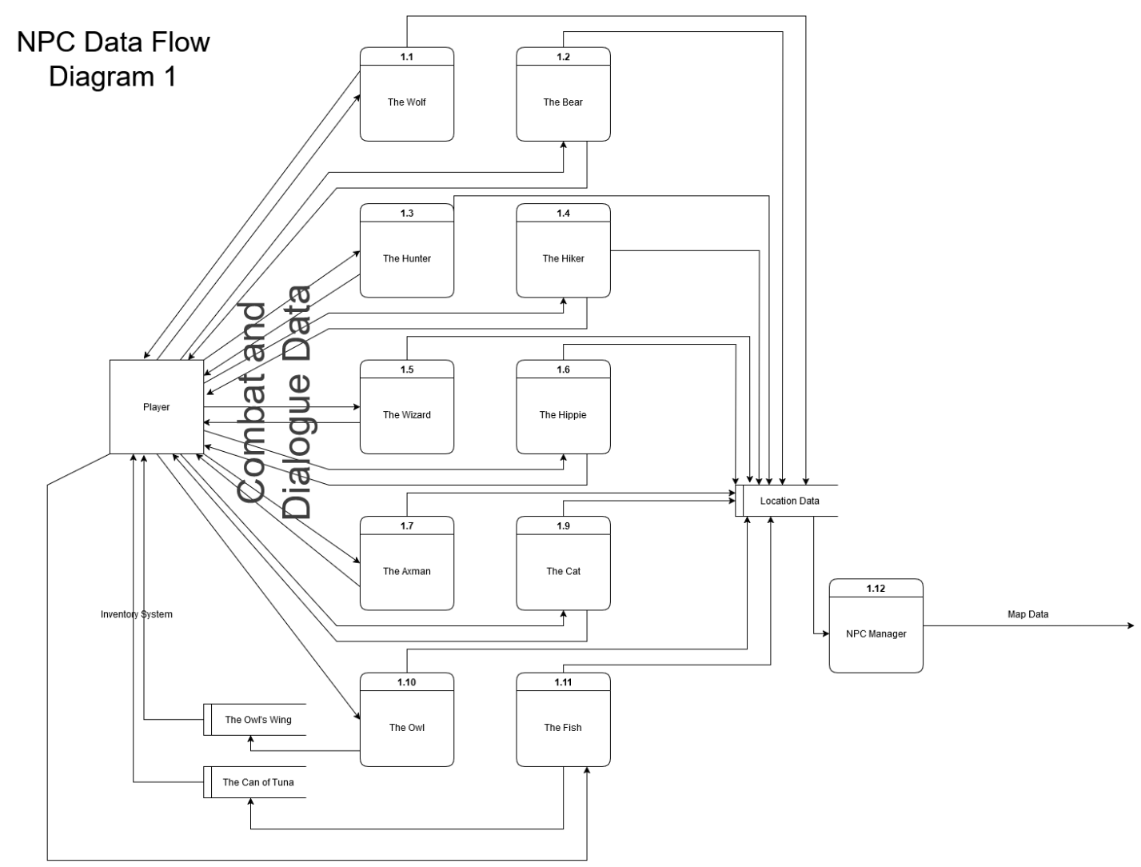

Data Flow Diagram Level 2:

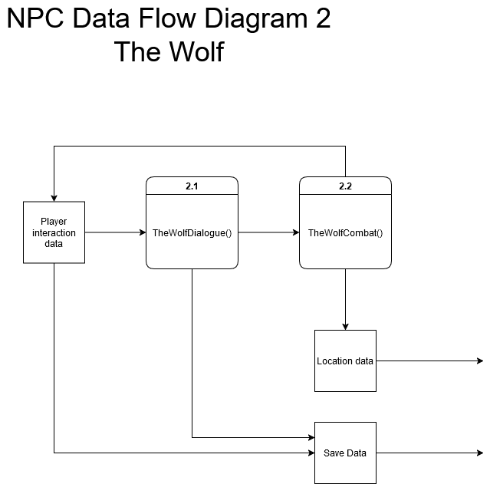

### Process Descriptions

TheWolfDialogue:

IF player activate button == true && proximity == close enough

Display dialogue boxes between Red and The Wolf

ELSE IF player attack hits The Wolf

IF Red has health && The Wolf has health

TheWolfCombat()

ELSE The Wolf remains standing still without speaking.

## Acceptance Tests ________9

Combat Testing:

1. Player spawns within range of NPC enemy
2. NPC enemy engages the player in combat
3. Player is attacked by NPC enemy, generating damage data
4. Damage data is recorded over period of time

## Timeline _________/10

### Work items

|  |  |  |
| --- | --- | --- |
| Task | Duration (Hours) | Predecessor Task(s) |
| 1. Requirements | 3 | - |
| 2. Program NPC Manager | 5 | 1 |
| 3. Program Game Object Manager | 2 | 1 |
| 4. Program NPCs superclass | 2 | 1 |
| 5. Program NPC dialogue system | 10 | 1 |
| 6. Programming NPC combat response | 10 | 1 |
| 7. Programming NPC dialogue for The Wolf | 2 | 4,5 |
| 8. Programming NPC dialogue for The Bear | 2 | 4,5 |
| 9. Programming NPC dialogue for The Hunter | 2 | 4,5 |
| 10. Programming NPC dialogue for The Hiker | 2 | 4,5 |
| 11. Programming NPC dialogue for The Wizard | 2 | 4,5 |
| 12. Programming NPC dialogue for The Hippie | 2 | 4,5 |
| 13. Programming NPC dialogue for The Axman | 2 | 4,5 |
| 14. Programming NPC dialogue for The Cat | 2 | 4,5 |
| 15. Programming NPC dialogue for The Owl | 2 | 4,5 |
| 16. Programming NPC dialogue for The Fish | 2 | 4,5 |
| 17. Testing | 10 | 1,2,3,4,5,6,7,8,9,10, 11,12,13,14,15,16 |

### Pert diagram

|  |  |  |
| --- | --- | --- |
| 3 | 5 | 8 |
| 2 | | |
| 8 | 5 | 13 |

|  |  |  |
| --- | --- | --- |
| 13 | 2 | 15 |
| 7 | | |
| 13 | 0 | 15 |

|  |  |  |
| --- | --- | --- |
| 13 | 2 | 15 |
| 8 | | |
| 13 | 0 | 15 |

|  |  |  |
| --- | --- | --- |
| 0 | 3 | 3 |
| 1 | | |
| 0 | 0 | 3 |

|  |  |  |
| --- | --- | --- |
| 3 | 2 | 5 |
| 3 | | |
| 11 | 8 | 13 |

|  |  |  |
| --- | --- | --- |
| 13 | 2 | 15 |
| 9 | | |
| 13 | 0 | 15 |

|  |  |  |
| --- | --- | --- |
| 15 | 10 | 25 |
| 17 | | |
| 15 | 0 | 25 |

|  |  |  |
| --- | --- | --- |
| 3 | 2 | 5 |
| 4 | | |
| 11 | 8 | 13 |

|  |  |  |
| --- | --- | --- |
| 3 | 10 | 13 |
| 5 | | |
| 3 | 0 | 13 |

|  |  |  |
| --- | --- | --- |
| 13 | 2 | 15 |
| 10 | | |
| 13 | 0 | 15 |

|  |  |  |
| --- | --- | --- |
| 3 | 10 | 13 |
| 6 | | |
| 3 | 0 | 13 |

|  |  |  |
| --- | --- | --- |
| 13 | 2 | 15 |
| 11 | | |
| 13 | 0 | 15 |

|  |  |  |
| --- | --- | --- |
| 13 | 2 | 15 |
| 12 | | |
| 13 | 0 | 15 |

|  |  |  |
| --- | --- | --- |
| 13 | 2 | 15 |
| 13 | | |
| 13 | 0 | 15 |

|  |  |  |
| --- | --- | --- |
| 13 | 2 | 15 |
| 14 | | |
| 13 | 0 | 15 |

|  |  |  |
| --- | --- | --- |
| 13 | 2 | 15 |
| 15 | | |
| 13 | 0 | 15 |

|  |  |  |
| --- | --- | --- |
| 13 | 2 | 15 |
| 16 | | |
| 13 | 0 | 15 |

### Gantt timeline

|  |  |  |  |  |  |  |  |  |  |  |  |  |  |  |  |  |  |  |  |  |  |  |  |  |  |
| --- | --- | --- | --- | --- | --- | --- | --- | --- | --- | --- | --- | --- | --- | --- | --- | --- | --- | --- | --- | --- | --- | --- | --- | --- | --- |
|  | 1 | 2 | 3 | 4 | 5 | 6 | 7 | 8 | 9 | 10 | 11 | 12 | 13 | 14 | 15 | 16 | 17 | 18 | 19 | 20 | 21 | 22 | 23 | 24 | 25 |
| 1 |  |  |  |  |  |  |  |  |  |  |  |  |  |  |  |  |  |  |  |  |  |  |  |  |  |
| 2 |  |  |  | 1 |  |  |  |  |  |  |  |  |  |  |  |  |  |  |  |  |  |  |  |  |  |
| 3 |  |  |  | 1 |  |  |  |  |  |  |  |  |  |  |  |  |  |  |  |  |  |  |  |  |  |
| 4 |  |  |  | 1 |  |  |  |  |  |  |  |  |  |  |  |  |  |  |  |  |  |  |  |  |  |
| 5 |  |  |  | 1 |  |  |  |  |  |  |  |  |  |  |  |  |  |  |  |  |  |  |  |  |  |
| 6 |  |  |  | 1 |  |  |  |  |  |  |  |  |  |  |  |  |  |  |  |  |  |  |  |  |  |
| 7 |  |  |  |  |  |  |  |  |  |  |  |  |  | 5 |  |  |  |  |  |  |  |  |  |  |  |
| 8 |  |  |  |  |  |  |  |  |  |  |  |  |  | 5 |  |  |  |  |  |  |  |  |  |  |  |
| 9 |  |  |  |  |  |  |  |  |  |  |  |  |  | 5 |  |  |  |  |  |  |  |  |  |  |  |
| 10 |  |  |  |  |  |  |  |  |  |  |  |  |  | 5 |  |  |  |  |  |  |  |  |  |  |  |
| 11 |  |  |  |  |  |  |  |  |  |  |  |  |  | 5 |  |  |  |  |  |  |  |  |  |  |  |
| 12 |  |  |  |  |  |  |  |  |  |  |  |  |  | 5 |  |  |  |  |  |  |  |  |  |  |  |
| 13 |  |  |  |  |  |  |  |  |  |  |  |  |  | 5 |  |  |  |  |  |  |  |  |  |  |  |
| 14 |  |  |  |  |  |  |  |  |  |  |  |  |  | 5 |  |  |  |  |  |  |  |  |  |  |  |
| 15 |  |  |  |  |  |  |  |  |  |  |  |  |  | 5 |  |  |  |  |  |  |  |  |  |  |  |
| 16 |  |  |  |  |  |  |  |  |  |  |  |  |  | 5 |  |  |  |  |  |  |  |  |  |  |  |
| 17 |  |  |  |  |  |  |  |  |  |  |  |  |  |  |  | 1,2,3,4,5,6,7,8,9,10,11,12,13,14,15,16 |  |  |  |  |  |  |  |  |  |